Rubric for Service Project PBL

I worked well with my group.
- Still learning 2. Sometimes 3. Almost Always
I showed my best work on my presentation.
- Still learning 2. Sometimes 3. Almost Always

I can name the needs in our community and how I can help.
- Still learning 2. Sometimes 3. Almost Always
I use good presentation skills.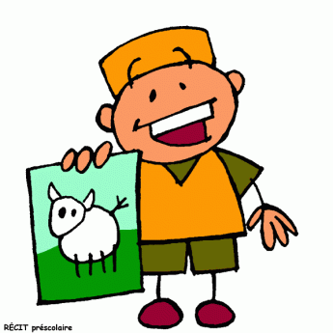
- Still learning 2. Sometimes 3. Almost Always

